

NAAN MUDHALAVAN PROJECT
PROJECT: LEASE MANAGEMENT
Team ID : NM2025TMID01338
Team Size : 4
Team Leader : Anusiya M
Team member : Subashini V
Team member : Sharu Mathumitha M
Team member : Pragathi Priya K

Salesforce Project– Lease Management System

1. Create Developer Account
- Go to https://developer.salesforce.com/signup
- Fill details: Name, Email, Role, Company, Country, Postal Code
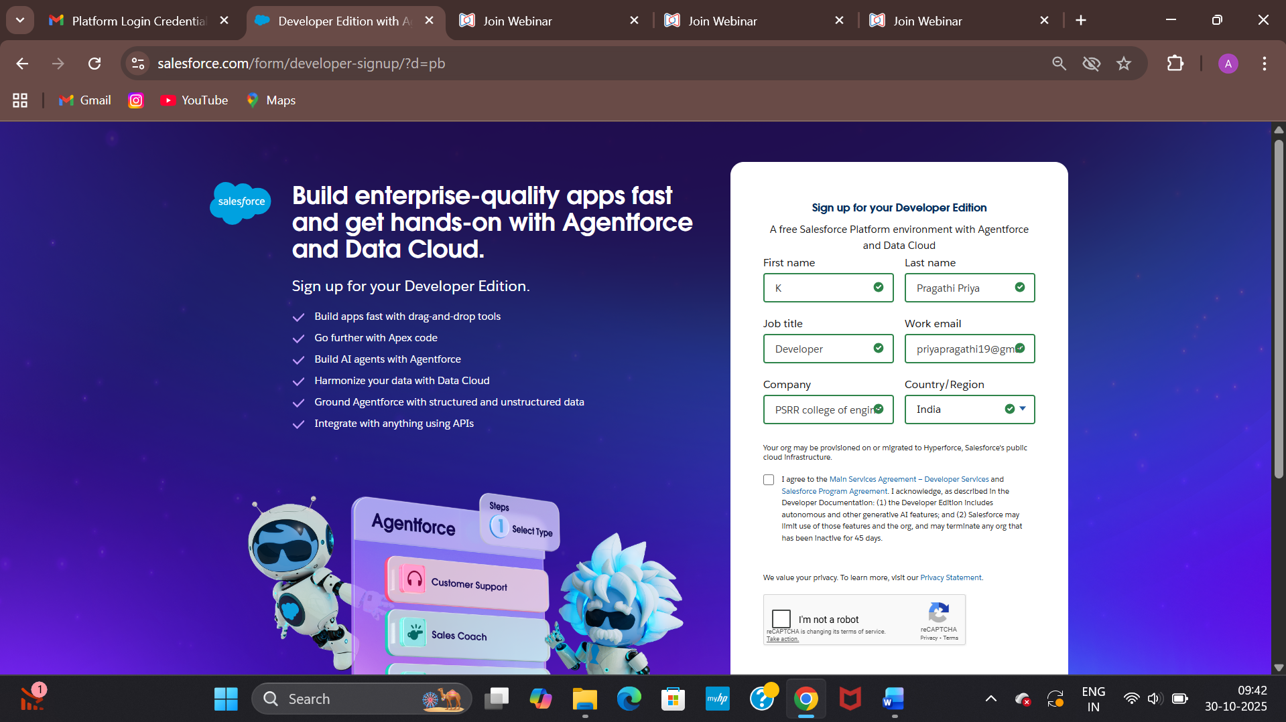
- Username format: yourname@college.com
- Verify email and set password
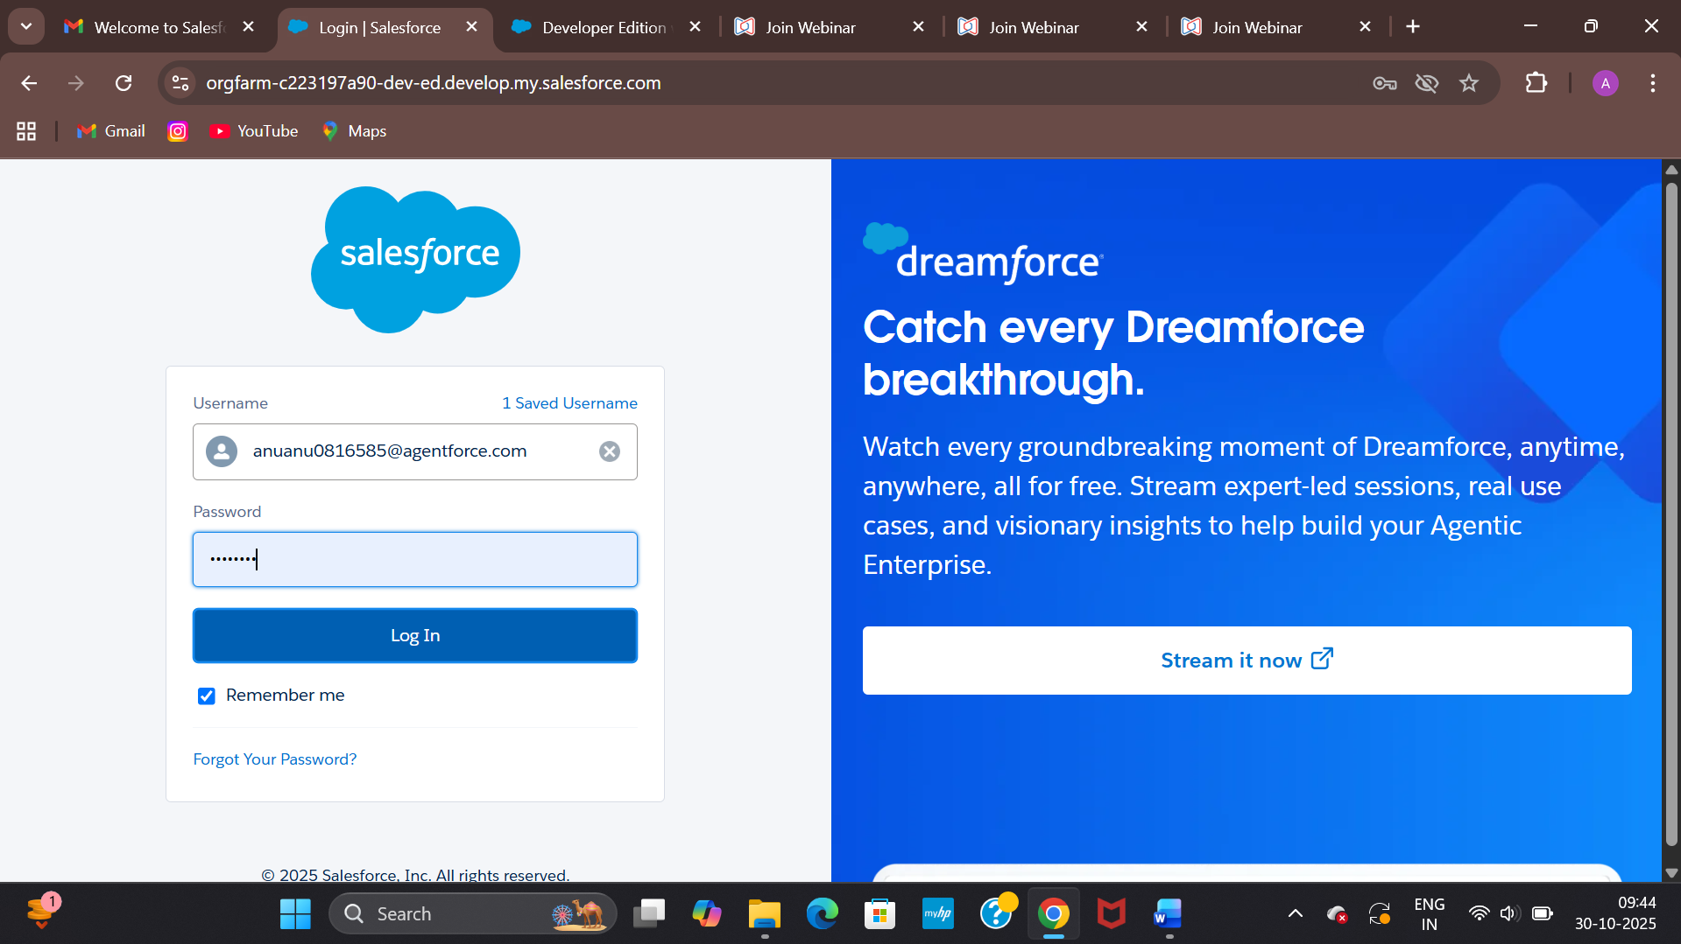

2. Create Objects
- Setup → Object Manager → Create → Custom Object
- Property, Tenant, Payment, and Lease objects created with proper field tracking

3. Create Tabs
- Setup → Tabs → New → Select Object → Choose Tab Style → Next → Save
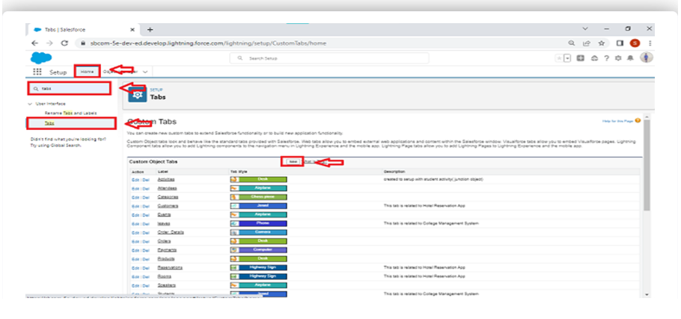
- Repeat for all objects

4. Create Lightning App
- Setup → App Manager → New Lightning App → Add all objects → Save & Finish
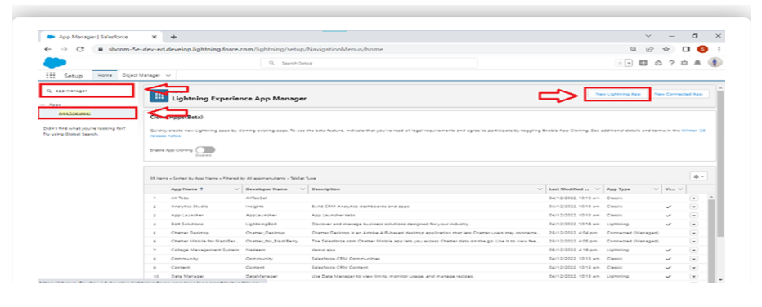
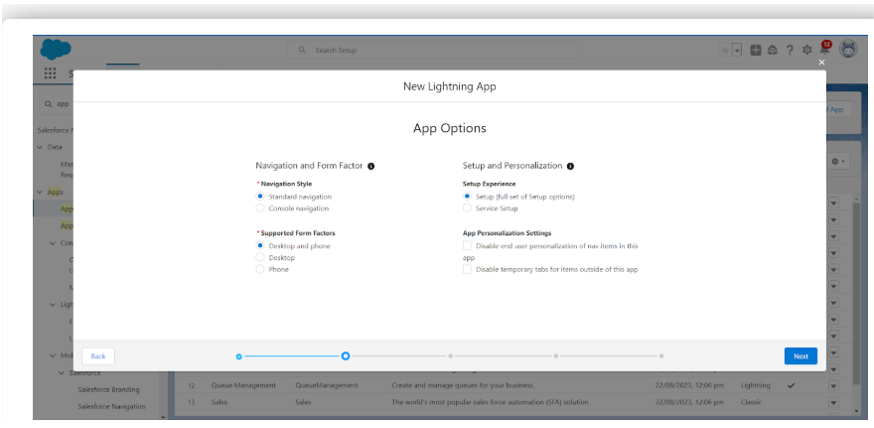
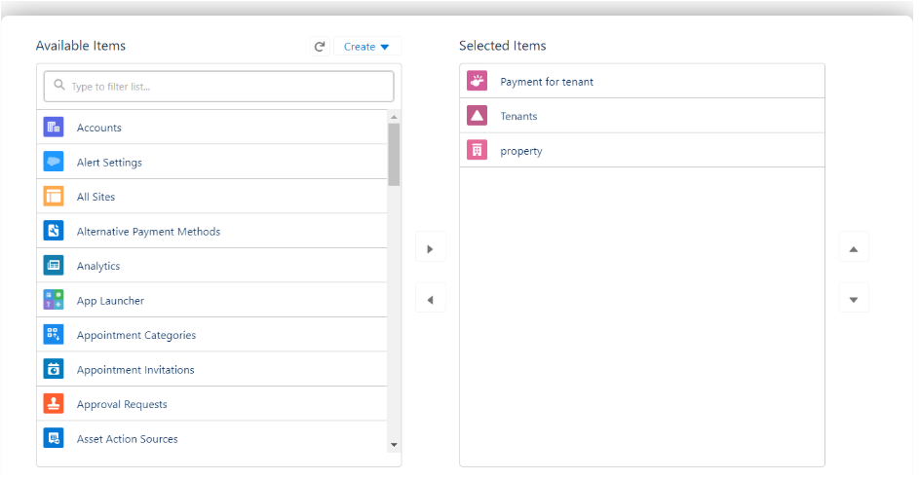
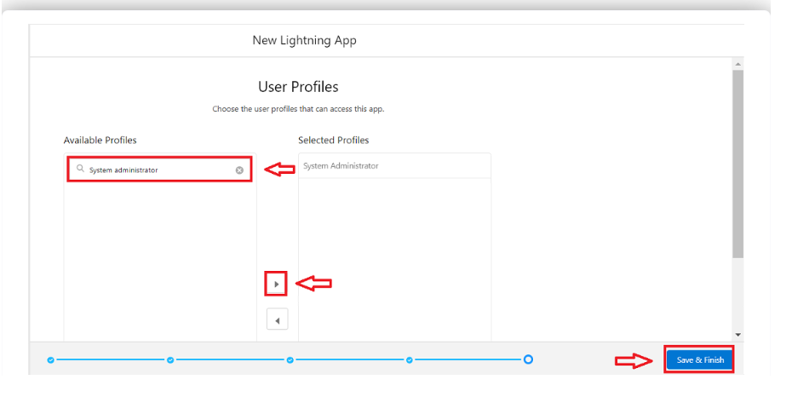

5. Create Fields
- Property: Name, Address, Type, Sqft
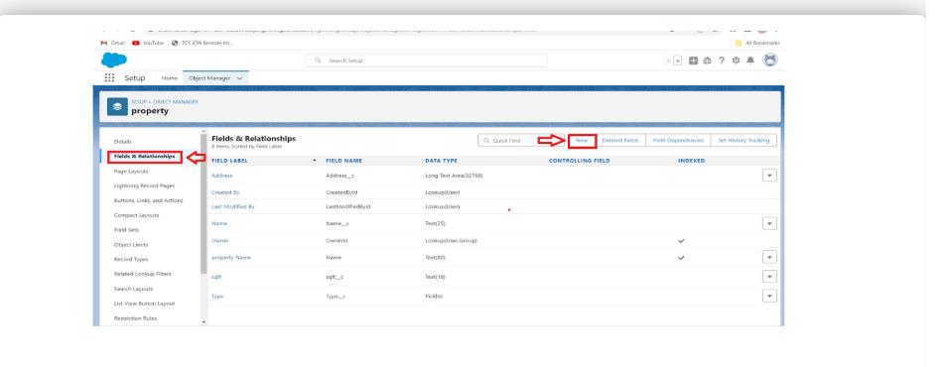
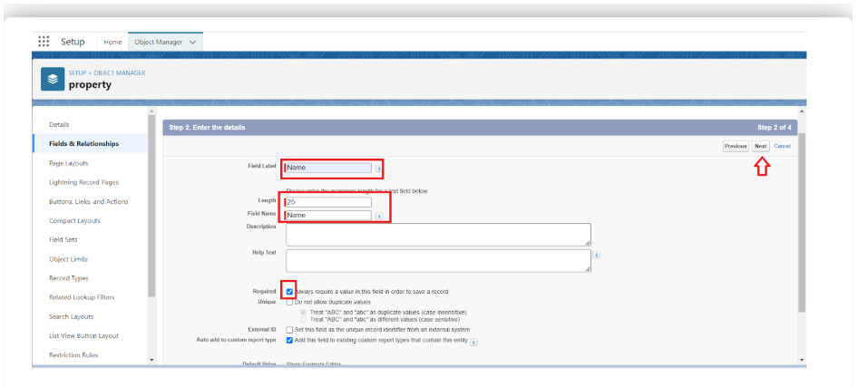
- Tenant: Email, Phone, Status
- Lease: Start Date, End Date
- Payment: Payment Date, Amount, Check for Payment

6. Create Relationships
- Lease → Lookup to Property
- Payment → Lookup to Tenant
- Property → Master-Detail to Payment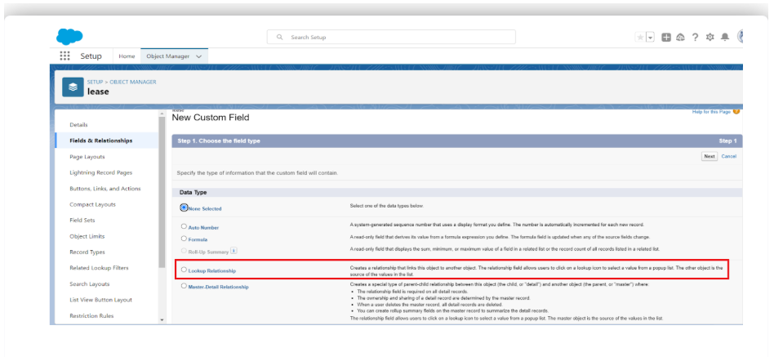

7. Create Validation Rule
- Object: Lease → Formula: End_date__c < Start_date__c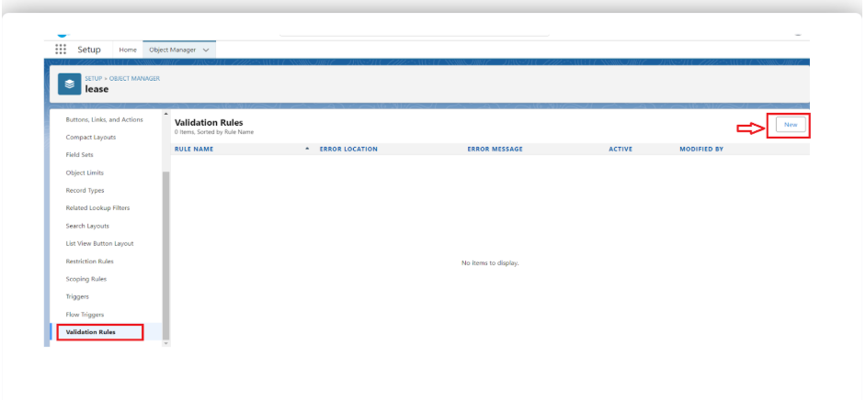
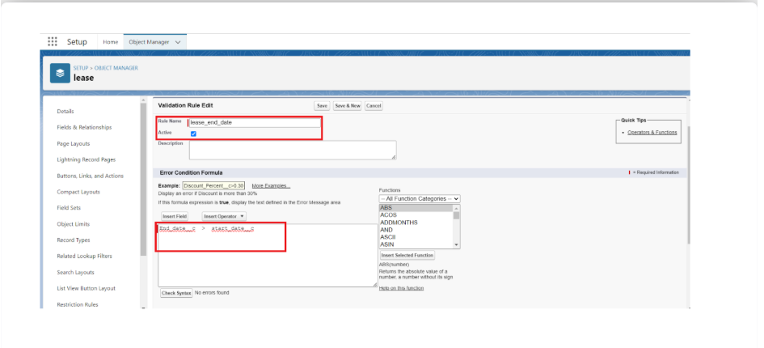
- Error Message: Your End date must be greater than start date
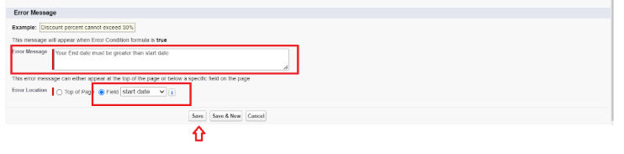

8. Create Email Templates
- Tenant Leaving, Leave Approved, Leave Rejected, Monthly Reminder, Payment Successful

9. Create Approval Process
- Setup → Approval Process → Tenant → New → Criteria: Tenant Status ≠ Leaving
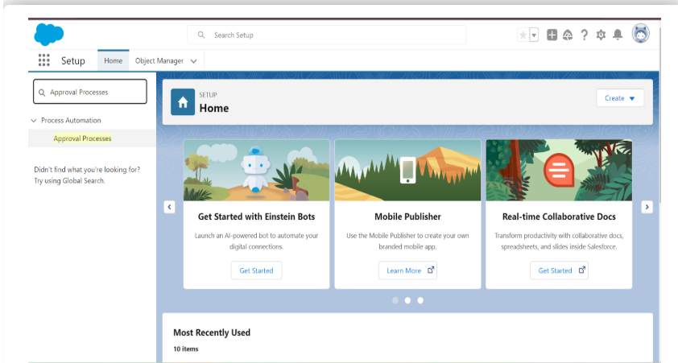
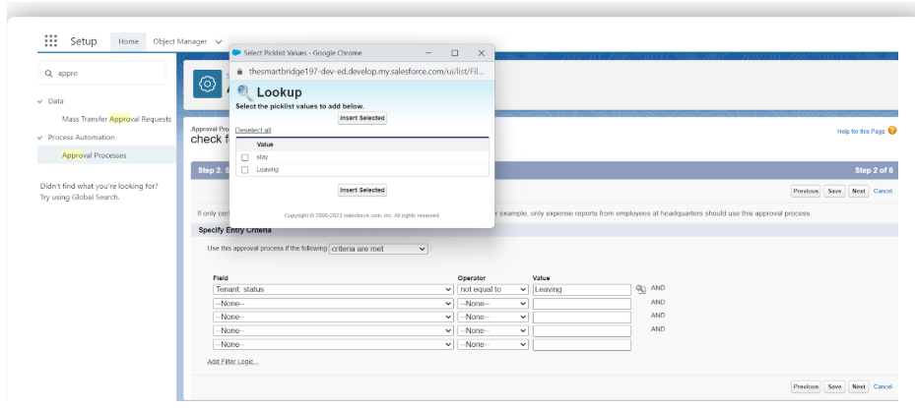
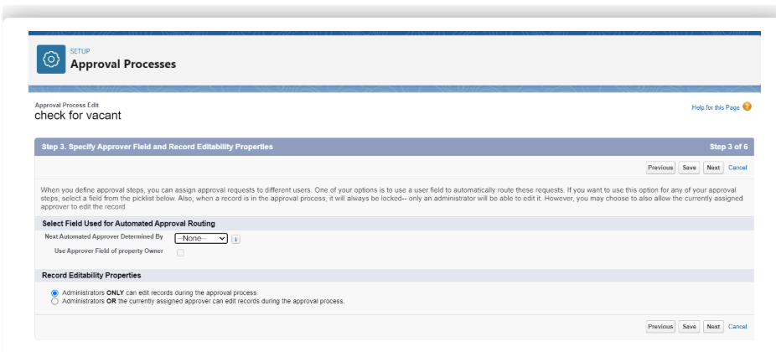
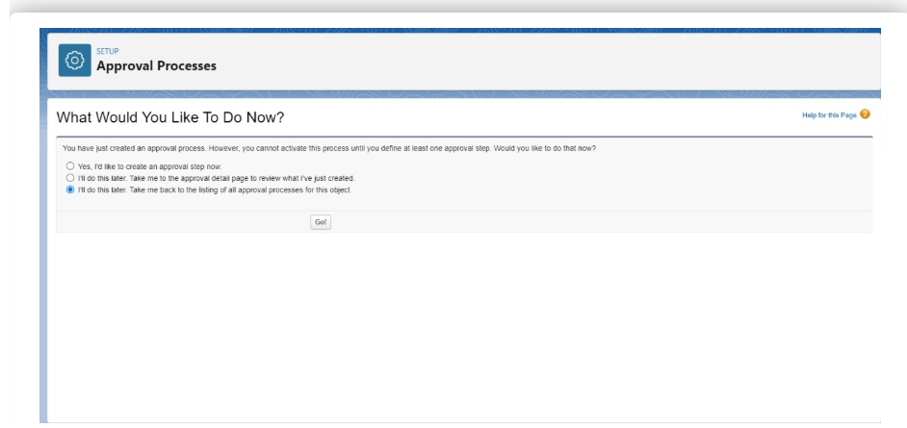
- Initial Submission: Tenant Leaving Email
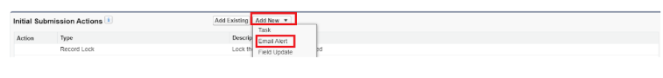
- Final Approval: Leave Approved Email
- Final Rejection: Leave Rejected Email

10. Create Apex Handler Class
- Use testHandler class to restrict tenant creation for same property
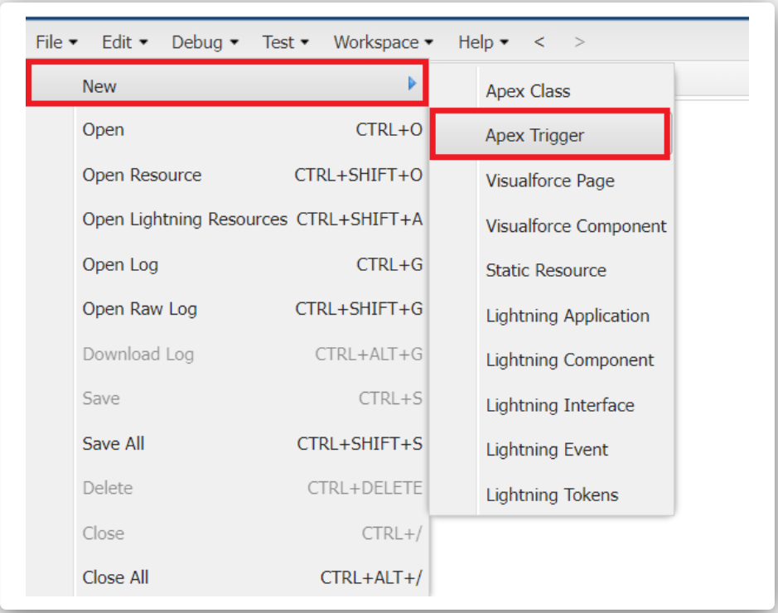
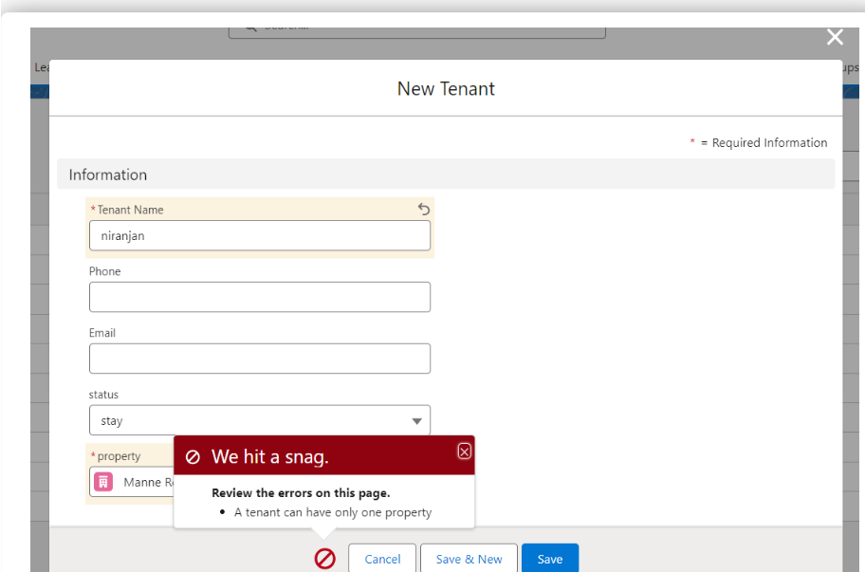
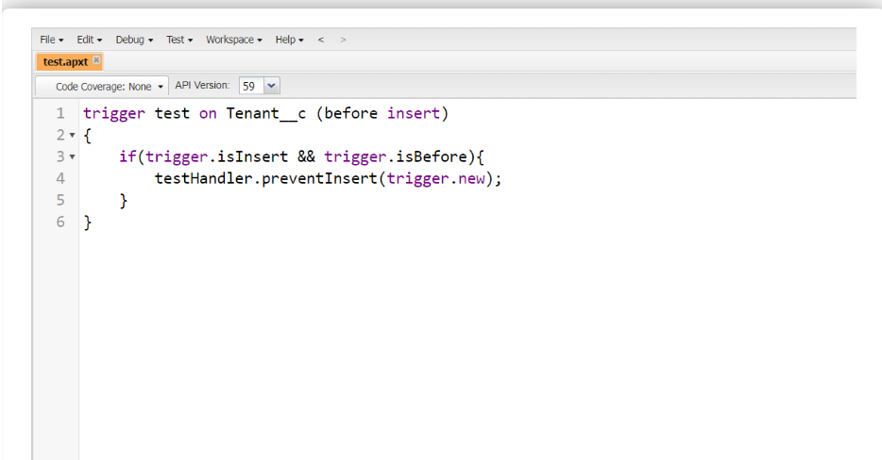

11. Create Flow (Monthly Payment)
- Record-Triggered Flow → Payment → When Paid → Send Email → Save & Activate
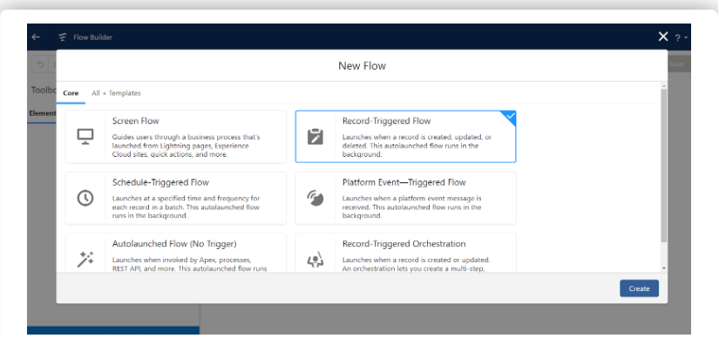
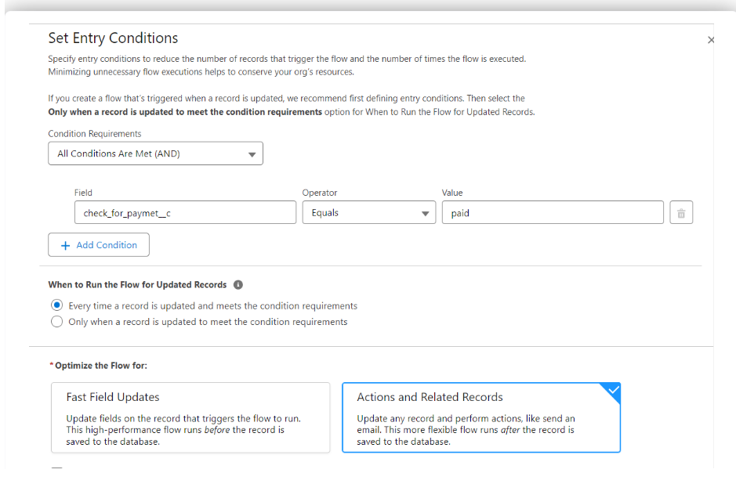

12. Create Schedule Apex Class
- MonthlyEmailScheduler → Send monthly rent reminder email to all tenants
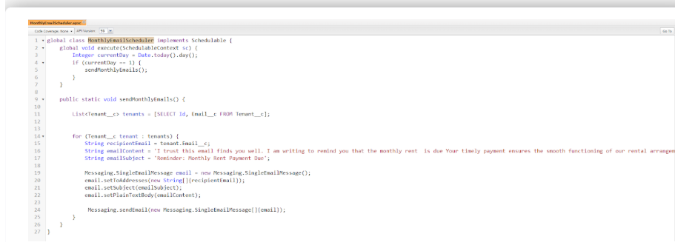

13. Schedule Apex
- Setup → Apex Classes → Schedule → Select MonthlyEmailScheduler → Set frequency & save
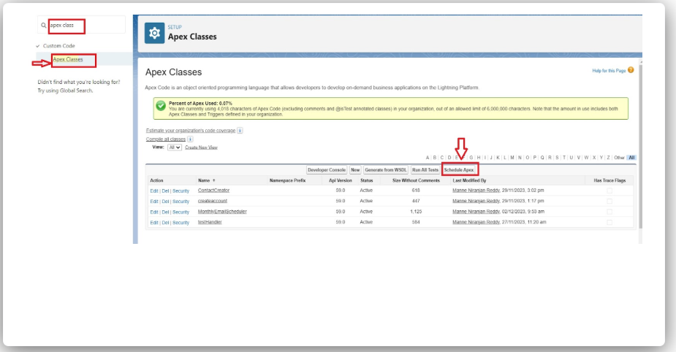
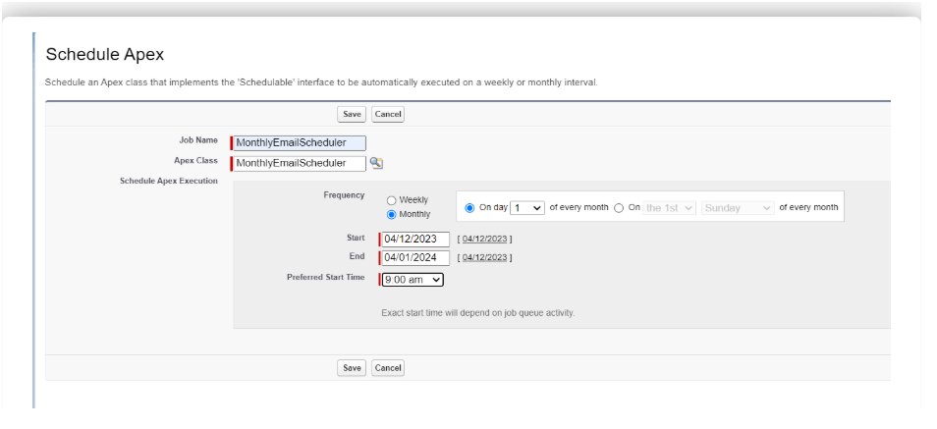

14. Test
- Submit approval → Approve/Reject → Verify email notifications
